Paul and Silas in Prison
Scripture: Acts 16:16-34

Starter: Would You Rather Singing Game
Directions: Simply ask your kids these silly questions about which places they would rather sing out loud. For added silliness and fun have them sing their answer to you.
- Would you rather sing out loud in the middle of a grocery store or at the zoo?
- Would you rather sing out loud during a test at school or while a couple is reciting their wedding vows?
- In the shower or in the kitchen?
- In your house or in your car?
- Alone or with people?
- While the pastor is talking at church or while your parents are trying to watch a movie?
Say: In the Bible story today, we will learn about when Paul and his friend Silas decided to sing out loud in a very unusual spot and situation.

Watch Video or Read Act 16: 16-34
https://www.youtube.com/watch?v=5t_3BuseTS0

Discussion Questions:
- Why were the slave girl’s owners upset at Paul and Silas?
- Paul had caused an evil spirit that could tell the future to leave the girl. The owners were using the girl’s ability to tell the future to make money. Now that the spirit was gone, they could no longer use the slave girl to make money.
- At midnight what were Paul and Silas doing in the jail cell? Why were they doing this? If you had just been hurt and thrown in prison, would you think to sing praises to God?
- They were praying and singing praises to God. Even though they were in a bad situation, they still had joy and trusted that God would take care of them.
- What or Who caused the jail cells to open and the chains to fall off the prisoners?
- God caused a large earthquake to open the cell doors and break the chains.
*End of questions if you only watched the video. Continue with the questions if you read the scripture.
- Did all the prisoners leave right when the doors opened?
- No
- Why was the jailer upset when he woke up and saw that the jail doors were open?
- It was his job to make sure the prisoners did not escape, and he would get in a lot of trouble if they had escaped while he was sleeping. He thought they were gone at first and he had failed his job.
- When the jailer saw that the prisoners were still there, what did he ask Paul and Silas?
- “Sirs, what must I do to be saved?”
- What do we need to do to be saved?
- Acts 16:31 “Believe in the Lord Jesus and you will be saved.”

Craft/Activity/Snack Options:
- Coloring Page: Download file from above.
- Paper plate tambourine craft:
Supplies: Paper plates, coloring materials, stapler, dried beans
Directions: Help your kids write “Make a joyful noise to the Lord” Psalm 100 on the bottom side of a paper plate. Then have your kids finish decorating the bottom side of that plate and another one if they want both sides decorated. Place some dried bean in the center of the 2 plates and staple them together bottom sides out. Your kids have just made a fun music maker Connect this craft to the bible story by relating it to when Paul and Silas made a joyful noise to the Lord even when they were in jail.
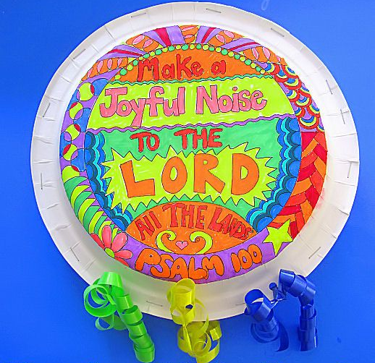
- Chain Craft:
Supplies: Paper, scissors, stapler, coloring materials
Directions: Cut out 6 strips of paper lengthwise and about 1-1.5 inches thick. Paper can be all different colors or it can be white so the kids can decorate more. On each slip of paper, write a word: “I am with you always.” And on one strip write “Matthew 28:20” Have you kids decorate the strips of paper however they would like. When they are finished staple the strips of paper together to make a paper chain. Explain how God was with Paul and Silas and proved it when He caused an earthquake and caused their chains to break. Explain how God is always with us too. You can also make the chain longer by leaving some strips with no writing like in the example below.

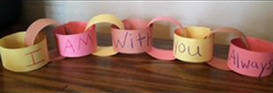
- Jailtime Snack
Supplies: Graham Crackers, Frosting, Pretzel sticks, Gummy Bears, (or anything you can improvise with )
Directions: Use supplies to construct a jailcell and place the gummy bears inside to represent Paul and Silas.

Prayer: Don’t forget to pray with your kids!

