Peter Denies Jesus

Starter:
Ask: What’s the biggest mistake a doctor can make? What about a pilot? A zookeeper? A chef? Hopefully you’ll get some creative answers here.

Watch Video: https://www.youtube.com/watch?v=EQ-IhXlhkE0

Discuss:
- What’s your favorite part of the video? What’s one thing you learned from it?
- What was Peter’s big mistake?
- Saying he didn’t know Jesus
- How many times did Peter say he didn’t know Jesus?
- 3 times
- Why do you think he lied about knowing Jesus?
- He was scared that he might get arrested and hurt too
- Read Isaiah 1:18. What does Jesus do with our sins? What do you think it means that we can be made white as wool?
- Forgives us, He washes away our sin so that we are white as wool. We can be forgiven and given a second chance because Jesus died on the cross for us to take away our sins and our mistakes.
- What is a big mistake you have made?
- No matter what mistakes you have made, Jesus will give you forgiveness just like he did for Peter.

Game:
Before the Rooster Crows
You’ll Need:
A box or bowl, three blocks or other objects to hide, and a rooster crow sound effect.
Here is a link to a rooster crow sound effect: https://www.youtube.com/watch?v=cSym5f2jySA

Hide the blocks/objects in the room and explain to your kids that the object of the game is to find and place all three hidden blocks/objects in the container before the rooster crows.

On your marks, get set, go! Have you kids begin the search. It is up to you when you want to make the rooster crow. Play multiple rounds and vary the time you give your kids before the rooster crows. Have your kids close their eyes or go into a different room to re-hide the objects.

Ask: How did it feel to have the rooster crow before you finished your task?
How do you think Peter felt when he heard the rooster crow and realized that he made a mistake and hurt Jesus?
The good news is that even when we really mess up, Jesus forgives us and gives us a second chance, just like He did for Peter

Craft Ideas:
- Coloring page. (Download from link above.)
- Make a cross craft. Here are some ideas:
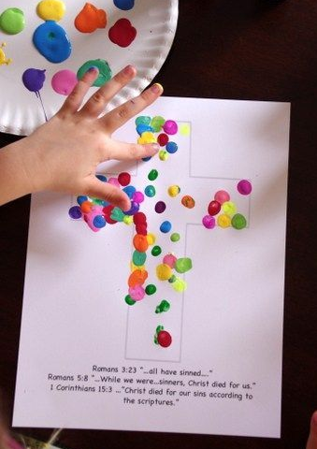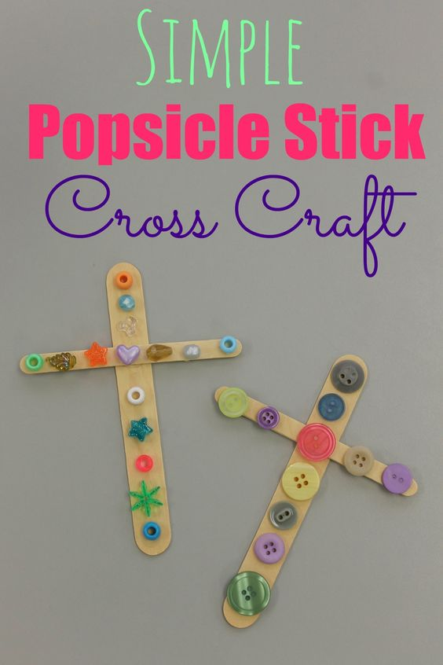
- Make a rooster craft. Download rooster color by number from above or here are some other ideas:
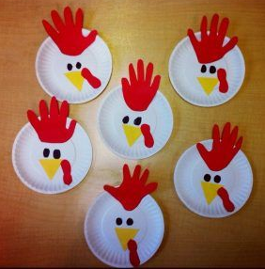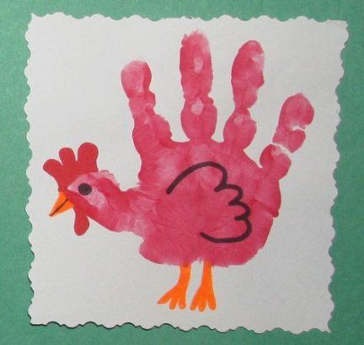

Pray: Thank God for His forgiveness and sending Jesus to die on the cross so that we can have a second chance even though we make mistakes.

